National Trends in Surgery for Sinonasal Malignancy and the Effect of Hospital Volume on Short Term Outcomes

David Ouyang1, Ivan El-Sayed2, Sue S. Yom12

Institutions: 1. Department of Radiation Oncology, University of California, San Francisco, San Francisco, CA, United States, 2. Department of Otolaryngology-Head and Neck Surgery, University of California, San Francisco, San Francisco, CA, United States

Corresponding Author:   
Sue S. Yom, MD, PhD  
Department of Radiation Oncology

Helen Diller Family Comprehensive Cancer Center

University of California, San Francisco

1600 Divisadero St. Suite H-1031

San Francisco, CA 94143   
[415-353-9893](tel:415-353-9893)  
[yoms@radonc.ucsf.edu](mailto:yoms@radonc.ucsf.edu)

Keywords: Paranasal Cancer, Sinonasal Surgery, National Inpatient Sample  
Running Title: Trends in Sinonasal Cancer Surgery

Tables: 4

Figures: 2

Supplemental Figures: 5  
  
Word Count:

**Abstract**

Objective/Hypothesis: Sinonasal carcinomas are rare, highly morbid neoplasms originating in the nasopharynx nasal cavity and paranasal sinuses. The mainstay of treatment over the past two decades is a combinations of surgery, radiation, and chemotherapy.. We sought to characterize the trends in initial management of sinonasal malignancy and the impact of hospital volume on surgical care and outcomes.

Methods: A retrospective cohort study with time trends of patients admitted for surgical resection of sinonasal malignancy in the National Inpatient Sample (NIS) between 1988 and 2009. Subset analysis of high risk casesis performed on patient cohorts with skull base involvement, orbital or maxillary sinus involvement, or requirement for radical neck dissection. Patient characteristics as well as hospital attributes are correlated with patient morbidity and mortality.

Results: Over the course of 22 years, we identified 3850 cases of sinonasal surgery patients from 879 hospitals. 14.9% of patients had complications and 0.8% of hospitalizations resulted in mortality. Older age was associated with higher morbidity and mortality. Cardiopulmonary complications, including pulmonary collapse and myocardial infarction, and infectious causes, most commonly urinary tract infection and surgical site infection, accounted for 13.5% and 34.6%, respectively, of all complications.

The high risk cases were associated withincreased morbidity and mortality. 24.4% of these high-risk surgeries were associated with complications, compared to 11.3% of cases without extra-sinonasal involvement. 32 hospitals averaged more than 5 cases per year, accountingfor 28% (1097) of all sinonasal surgeries. These hospitals were likewise overrepresented in high risk cases – accounting for 32.4% of cases requiring neck dissection, 44.9% of cases with orbital involvement, and 45.7% of cases with skull base involvement.

Conclusions: This study reflects current trends in the management of sinonasal cancer, with a increased likelihood complicated surgeries being performed at higher-volume hospitals which also had a higher complication rateComplicated cases resulted in higher rates of complications but were not associated with higher mortality.

**Introduction**

Sinonasal cancers are uncommon – accounting for only between 1 – 3% of head and neck cancers [1,2]. Awide range of tumors can originate in the sinonasal cavities including squamous cell carcinoma, adenocarcinomas, and neuroendocrine carcinomas. Sinonasal carcinomas are typically asymptomatic until they progress to advance stage withlocal invasion and a potential constellation of symptoms including chronic nasal discharge, epistaxis, nasal obstruction, anosmia, neuropathies, proptosis, edema, and visual disturbances. Depending on the tumor type, regional lymph node or distant metastases occur with varying frequency. Due to proximity to vital structures such as the orbit, carotid artery, and brain, primary tumors typically present as advanced disease.

Given the low incidence and heterogenous histology of sinonasal cancers, there are no randomized trials indicating the optimal management. Management of sinonasal cancers varies with histology, but the current standard approach has tradiationally been combined modality treatment with surgery and radiotherapy for advanced stage disease with or without chemotherapy. Several retrospective studies suggest improved local control is achieved when surgery is employed, however selection bias of unresectable tumors may influence the poorer results with radiation. (reference ) Although there is a high incidence of local recurrence, there is insufficient high-level evidence to prove the superiority of either approach.

A few institutions have published their experiences with sinonasal cancers [1,3,4,5,6,7], but these institutional case series each have fewer than 75 patients and represent different perspectives treatment and overall approach to sinonasal cancers over prolonged time periods. The University of Florida experience using primarily radiotherapy-only approach and combined radiotherapy surgical approach found the control rate with radiotherapy alone was 43%, while combined modality was 84% with primary surgery followed by radiation.( Mendenhall WM, Amdur RJ, Morris CG, et al. Carcinoma of the nasal cavity and paranasal sinuses. Laryngoscope2009;119:899–906. ). Similarily the M.D. Anderson Cancer Center experience with more inclusion of surgery and post-operative radiotherapy achieved 82% 5-year survival. Case studies have suggested a rate of local recurrence of 28-41% and 5-year actuarial survival rates of 40-82%.

While surgery in combination with radition plays a definitive role in the management of many sinonasal cancers, limited data exists regarding how surgical care is delivered across the United States. Sinonasal and skull base surgery is specialized surgery that benefits from multidisciplinary teams, with potential for immediate severe or life threatening complications which may availiability of surgical treatment. We sought to examine contemporary patterns of sinonasal cancer surgery. In this study, through analysis of a national inpatient database, we investigate the surgical outcomes of patients who underwent sinonasal cancer surgery and evaluate the impact of hospital volume on short-term outcomes.

**Materials and Methods**

**Data Source**

A retrospective cross-sectional analysis of patients who underwent surgical resection of primary cancer of nasal cavities and paranasal sinuses was performed using data from the National Inpatient Sample (NIS) from the Healthcare Cost and Utilization Project, Agency for Healthcare Research and Quality. The NIS is the largest database of all-payer inpatient discharge information, sampling approximately 20% of all non-federal US hospitals and including approximately 9 million hospital admissions each year. Each NIS entry includes all diagnosis and procedure codes of activity during the patient’s hospitalization at the time of discharge as well as patient demographics, hospital characteristics, and short-term complications of the hospitalization.

**Data Extraction**

All available data from 1988 through 2009 were queried. Patients admitted for primary head and neck cancer with a primary procedure of surgical resection in the maxillary, frontal, ethmoid, or sphenoid sinuses were identified. Higher-risk surgeries were identified by orbital or skull base involvement as well as surgeries requiring neck dissection. Hospital mortality andperioperative morbidity such as post-operative infections, cardiopulmonary complications, hemorrhagic complications, nerve palsies, and deep vein thrombosis were identified.

**Statistical Analysis**

The total number of hospitalizations was plotted annually from 1988 to 2009 and hospital volume was also assessed for each hospital in the database. Hospital-level data was stratified by hospital caseload to compare complication rates between high- and low-volume hospitals. The Pearson chi-square test was used to analyze differences in low-volume and high-volume hospitals as well as differences in complication rates. Logistic regression models were used to assess the influence of patient demographics and hospital characteristics on complication rates. All analyses were performed using Python 2.7 (Python Software Foundation, www.python.org) and R 2.13 (R Foundation, www.r-project.org).

**Results**

We identified 3850 cases of sinonasal surgery between 1988 and 2009 (Figure 1). Patients had a mean age of 61 years old and stayed on average 6.8 days in the hospital. Consistent with previous accounts, we found a male predominance, comprising 57.2% of all patients. Aggregate patient race, sex, age, and insurance status did not vary between high and low volume centers (Table 1), and the overall demographics have not changed over time (Supplemental Figure A, B, C). The volume of sinonasal cancer surgery has not changed appreciably over the last twenty years, but a greater proportion of these surgeries are now being performed at higher-volume centers (Figure 1, R2 = 0.268, p > 0.001).

|  |  |  |  |  |  |  |  |  |  |  |  |
| --- | --- | --- | --- | --- | --- | --- | --- | --- | --- | --- | --- |
| **Table 1.** Patient Demographics for Sinonasal Cancer Surgery | | | | | | | | | | | |
|  |  | | **High Volume Centers  (>5 Cases/Year)** | | | | **Low Volume Centers (>5 Cases/Year)** | | | |  |
| Age, mean (SD) | | | 59.8 ± 14.3 | | | | 62.0 ± 17.2 | | | |  |
|  |  | |  | |  | | | |  | | |
| Sex, n (%) | Female | | 424 (40.0) | | | | | 1214 (43.5) | | |  |
|  | Male | | 633 (60.0) | | | | | 1568 (56.2) | | |  |
|  |  |  | |  | | | |  | |  | |
| Race, n (%) | White | | 632 (59.6) | | | | | 1424 (51.1) | | |  |
|  | Black | | 53 (5.0) | | | | | 214 (7.7) | | |  |
|  | Hispanic | | 54 (5.1) | | | | | 163 (5.8) | | |  |
|  | Asian/Pacific Islander | | 30 (2.8) | | | | | 65 (2.3) | | |  |
|  | Native American | | 1 (0.1) | | | | | 9 (0.0) | | |  |
|  | Other or unknown | | 271 (26.0) | | | | | 879 (31.5) | | |  |
|  |  | |  | |  | | | |  | | |  |
| Primary payer, n (%) | Private | | 440 (41.5) | | | | | 1288 (46.2) | | |  |
| Medicaid | | 69 (6.5) | | | | | 214 (7.7) | | |  |
|  | Medicare | | 480 (45.2) | | | | | 1066 (38.2) | | |  |
|  | Self-pay | | 40 (3.8) | | | | | 75 (2.7) | | |  |
|  | Other or unknown | | 27 (2.5) | | | | | 110 (3.9) | | |  |
|  |  | |  | |  | | | |  | | |  |
| **Total, n (%)** |  | | **1061(28.5)** | | | **2789 (71.5)** | | | | |  |

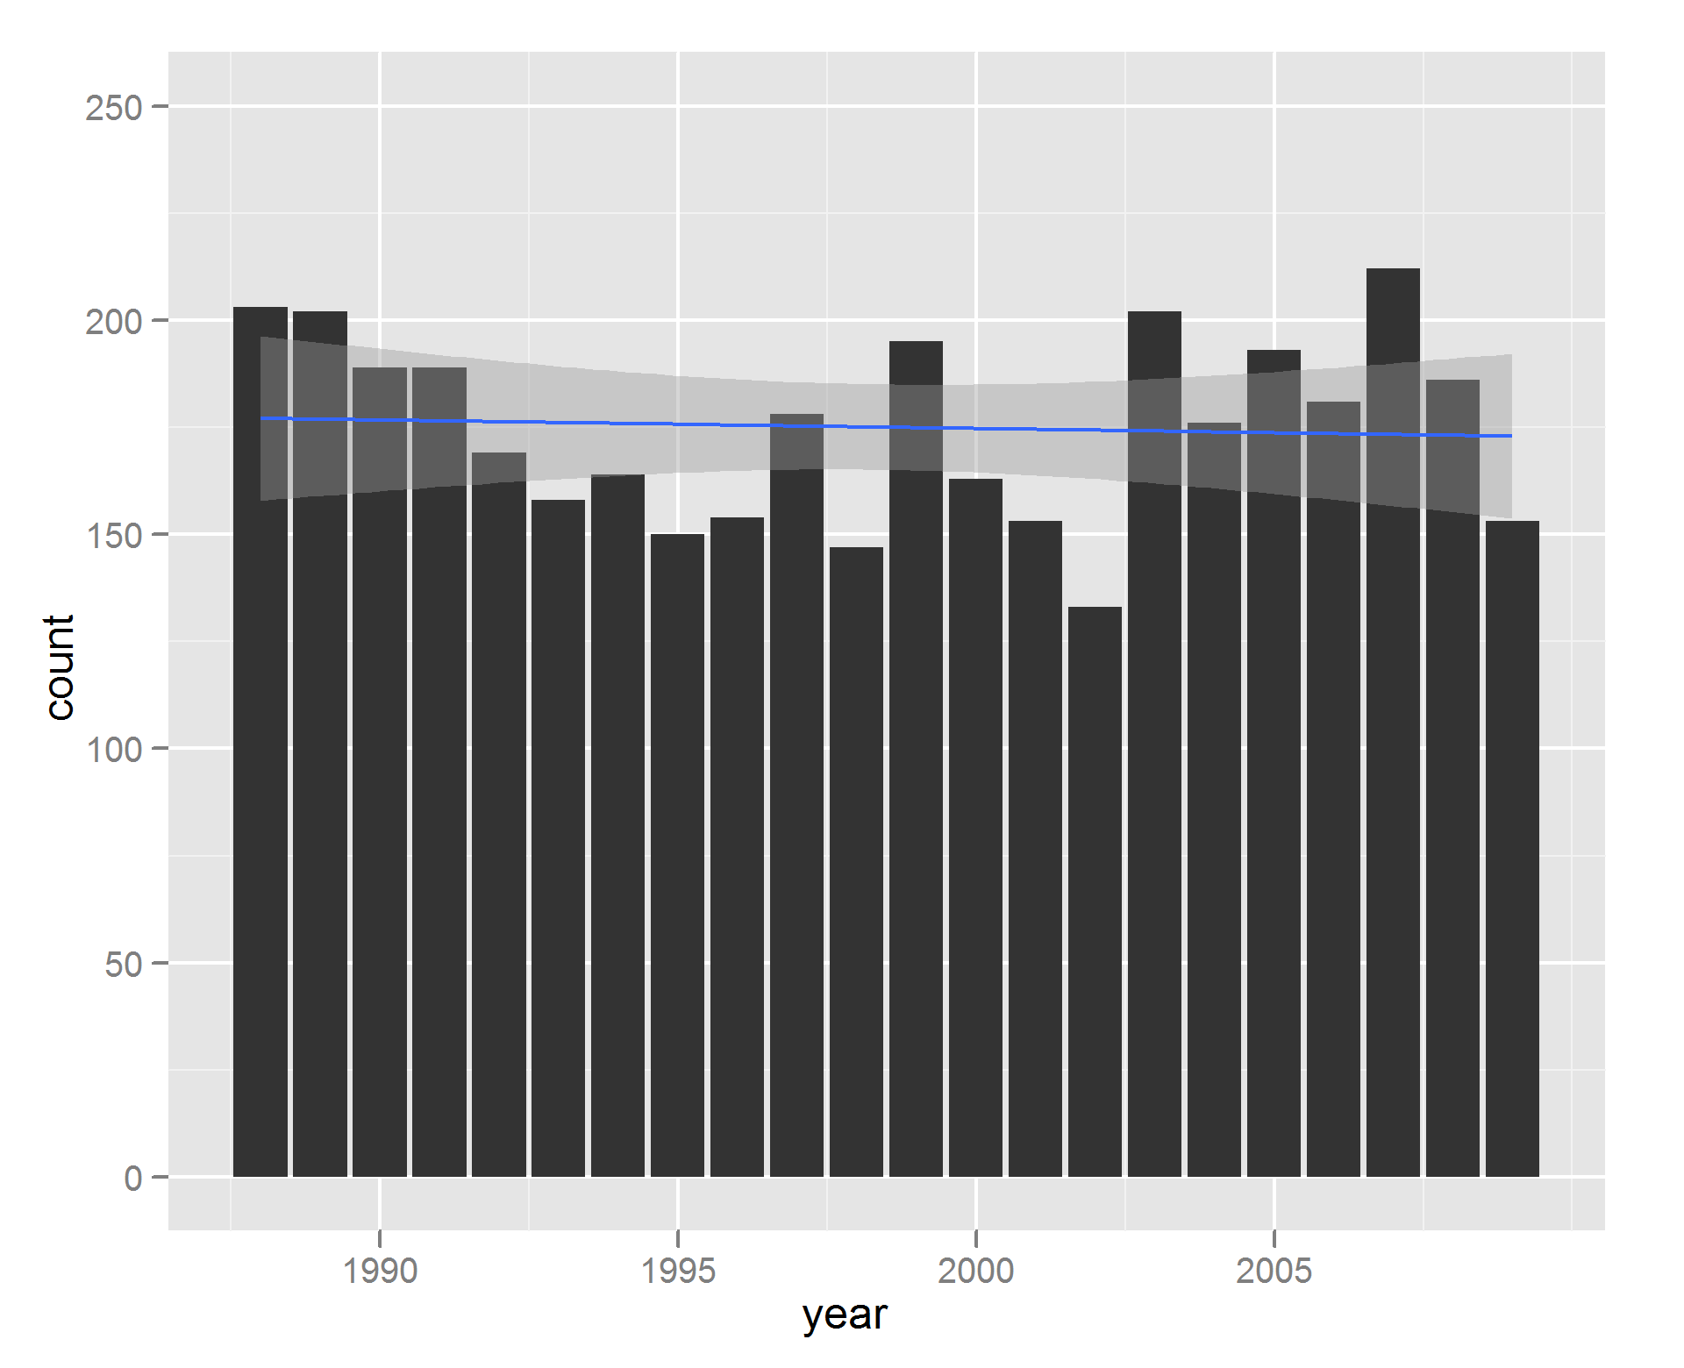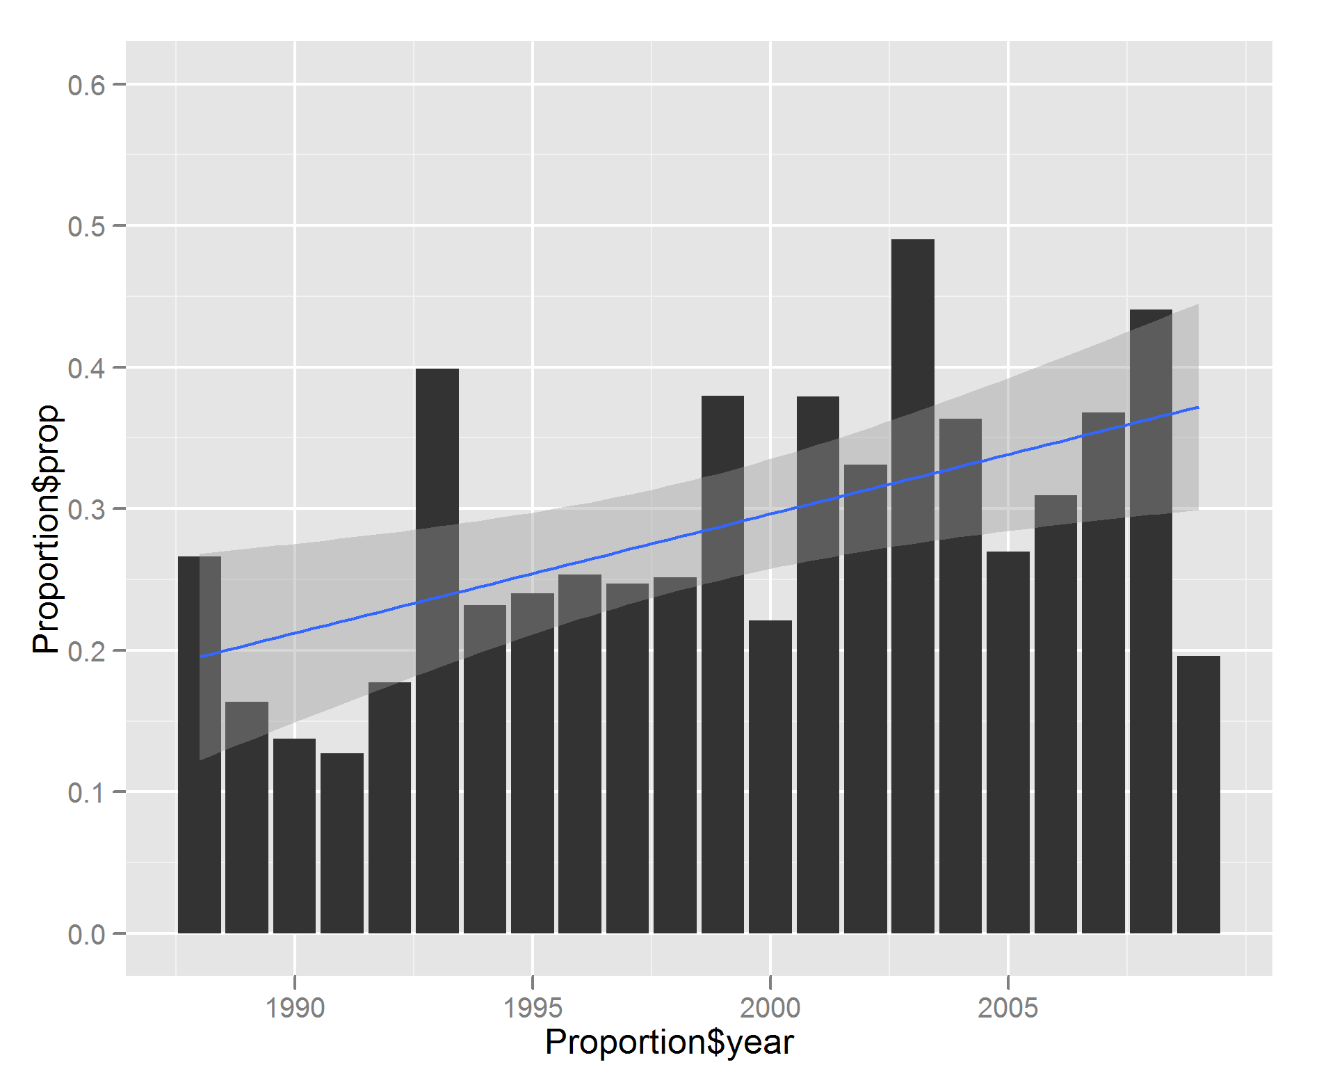

**Figure 1: Percentage of Low- and High-Volume Hospital Management over Time (by Year)**

In order to investigate the impact of surgical volume on short-term outcomes, we separated hospitals into centers that perform relatively higher numbers of sinonasal cancer surgery cases (greater than 5 cases per year) and centers that performed relatively few sinonasal cancer surgery cases (less than 5 cases per year). Thirty two hospitals which averaged more than 5 cases per year were identified and accounted for 28% of all sinonasal surgery cases. These hospitals were more frequently represented in high-risk cases, accounting for 32.4% of cases requiring neck dissection, 44.9% of cases with orbital involvement, and 45.7% of cases with skull base involvement, despite comprising only 3.6% of all hospitals that performed sinonasal cancer surgery (Table 2). High-volume centers tended to be teaching hospitals (P > 0.001), and large, urban hospitals were also more represented (Table 3).

|  |  |  |  |  |  |  |
| --- | --- | --- | --- | --- | --- | --- |
| **Table 2.** Number of Hospitals, Sinonasal Cancer Surgeries Stratified by Hospital Caseload | | | | | |  |
|  | **1988 to 2009** | | | | |  |
|  | **Hospitals, n (%)** | **Cases (%)** | **Cases with Neck Dissection (%)** | **Cases with Orbital Involvement (%)** | **Cases with  Skull Base Involvement (%)** | **Complicated Cases,  Total (%)** |
| High Volume Hospitals (>5 Cases/Year) | 32 (3.6) | 1061 (28.5) | 79 (32.4) | 106 (44.6) | 128 (43.1) | 277 (38.7) |
| Low Volume Hospitals (<5 Cases/Year) | 847 (96.4) | 2789 (71.5) | 165 (67.6) | 130 (53.4) | 169 (56.9) | 418 (61.3) |
| **Total** | **879 (100)** | **3,850 (100)** | **244 (100)** | **236 (100)** | **297 (100)** | **715 (100)** |
|  |  |  |  |  |  |  |

|  |  |  |  |  |  |  |  |  |
| --- | --- | --- | --- | --- | --- | --- | --- | --- |
| **Table 3.** Hospital Characteristics of Admissions for Sinonasal Cancer Surgery | | | | | | | | |
|  | |  | **High Volume Centers  (>5 Cases/Year)**a | | | **Low Volume Centers (>5 Cases/Year)**a | |  |
| Hospital size, n (%)b | Small | | 3 (10.0) | | | 113 (13.6) | | |
| Medium | | 5 (16.7) | | | 254 (30.7) | | |
|  | Large | | 22 (73.3) | | | 461 (55.7) | | |
|  |  | |  |  | | |  | |  |
| Hospital type, n (%) | Teaching | | 27 (90.0) | | | 346 (41.8) | | |
| Non-teaching | | 3 (10.0) | | | 482 (58.2) | | |
|  |  | |  |  | | |  | |  |
| Hospital location, n (%) | Urban | | 29 (96.7) | | | 707 (85.4) | | |
| Non-urban | | 1 (3.3) | | | 121 (14.6) | | |
|  |  | |  |  | |  | | |  |
| Complex Cases,  n (%)c | Neck Dissection | | 79 (7.4) | | | 165 (5.9) | | |  |
| Orbital Involvement | | 106 (10.0) | | | 130 (4.7) | | |  |
| Skull Base Involvement | | 128 (12.0) | | | 169 (6.1) | | |  |
|  | |  |  |  | |  | | |  |
| **Total, n (%)** | |  | **32 (100.0)** | | **847 (100.0)** | | |  |
| Data are cumulative, 1988-2009. aHospital characteristics were not found for 2 high volume hospitals and 19 low volume hospitals.  bHospital size classification is dependent on number of beds and hospital type. For example, for urban, teaching hospitals, “small” signifies < 300 beds and “large” signifies > 500 beds. cPercentage obtained from total number of cases by each subset | | | | | | | | |

Less than 1% of hospitalizations resulted in short-term mortality and 36.9% of patients had complications ranging from neuropathies and visual impairment to infections and cardiopulmonary arrest (Table 4). Cardiopulmonary complications were the most common class of complications, representing about half of all complications, while visual defects and neuropathies directly resulting from the surgery was present in a minority of cases. There was a statistically significant difference in overall complication rate between high-volume and low-volume centers (Chi-squared test, p = 0.018), with higher rates of cardiopulmonary complications (p = 0.024) and peri-operative electrolyte abnormalities (p = 0.002) seen at high-volume centers. There was no difference in mortality between high-volume and low-volume centers (p = 0.122).

There were 715 cases that included neck dissection, had orbital or maxillary sinus involvement, or had skull base involvement, of which 277 were performed at high-volume centers and 418 were performed at low-volume centers. Two cases had surgeries that met all three criteria and 59 patients had surgeries that met two of the three criteria. These complicated cases had a mean length of stay of 9.4 days (vs. 6.2 days for uncomplicated cases, p < 0.0001) and had higher rates of morbidity and mortality. Among these high-risk surgeries, 29.4% resulted in the listed complications, compared to 23.2% of cases without such extra-sinonasal intervention (p < 0.0001). For complicated cases, there was no observed difference in overall complication rate or mortality between high-volume and low-volume centers.

|  |  |  |  |  |  |  |  |
| --- | --- | --- | --- | --- | --- | --- | --- |
| **Table 4.** Complications of Sinonasal Cancer Surgery | | | | | | | |
|  | **Total** | **High-Volume Centers** | | **Low-Volume Centers** | | | **Pa** |
| Deaths, n (%) | 30 (0.8) | 4 (0.4) | | 26 (0.9) | | 0.122 | |
|  |  |  | |  |  | | |
| Infectious, n (%) |  |  | |  | | 0.119 | |
| Surgical Site Infection | 70 (1.8) | 14 (1.3) | | 56 (2.0) | |  | |
| Urinary Tract Infections (UTIs) | 71 (1.8) | 16 (1.5) | | 55 (2.0) | |  | |
| Pneumonia | 30 (0.8) | 9 (0.8) | | 21 (0.8) | |  | |
| Unspecified Postop Infection | 17 (0.4) | 3 (0.2) | | 14 (0.5) | |  | |
|  |  |  | |  | |  | |
| Cardiopulmonary, n (%) |  |  | |  | | 0.024b | |
| Stroke | 16 ((0.4) | 8 (0.8) | | 8 (0.3) | |
| Cardiac Arrest | 8 (0.2) | 1 (0.1) | | 7 (0.3) | |  | |
| Other Cardiac Complications | 456 (11.8) | 127 (12.0) | | 329 (11.8) | |  | |
| Pulmonary Complications | 239 (6.2) | 87 (8.2) | | 152 (5.4) | |  | |
|  |  |  | |  | |  | |
| Other, n (%) |  |  | |  | |  | |
| Neuropathies  Visual Impairment | 51 (1.3) | 13 (1.2) | | 38 (1.4) | | 0.861 | |
| 76 (2.0) | 20 (1.9) | | 56 (2.0) | | 0.908 | |
| Hemorrhage | 46 (1.2) | 12 (1.1) | | 34 (1.2) | | 0.953 | |
| Electrolyte Abnormalities | 312 (8.1) | 110 (10.4) | | 202 (7.2) | | 0.002b | |
|  |  |  |  | | |  | |
| **Total Complications** | **1392 (36.9)** | 424 (40.0) | | 998 (35.8) | | 0.018b | |
| aChi Square Test Comparing High-Volume and Low-Volume Centers. b P < 0.05 | | | | | | | |

Over the time period of analysis, an increasingly greater proportion of cases were done at high volume centers (Figure 1). At the same time, a greater number of cases required neck dissection or had orbital sinus, maxillary sinus, or skull base involvement (Figure 2). There was a decrease in mortality over time (p < 0.001), however concomitantly there was an increase in the complicate rate (Figure 3). The make-up and distribution of the types of complications has not changed during the time period of analysis (Supplemental Figure D).

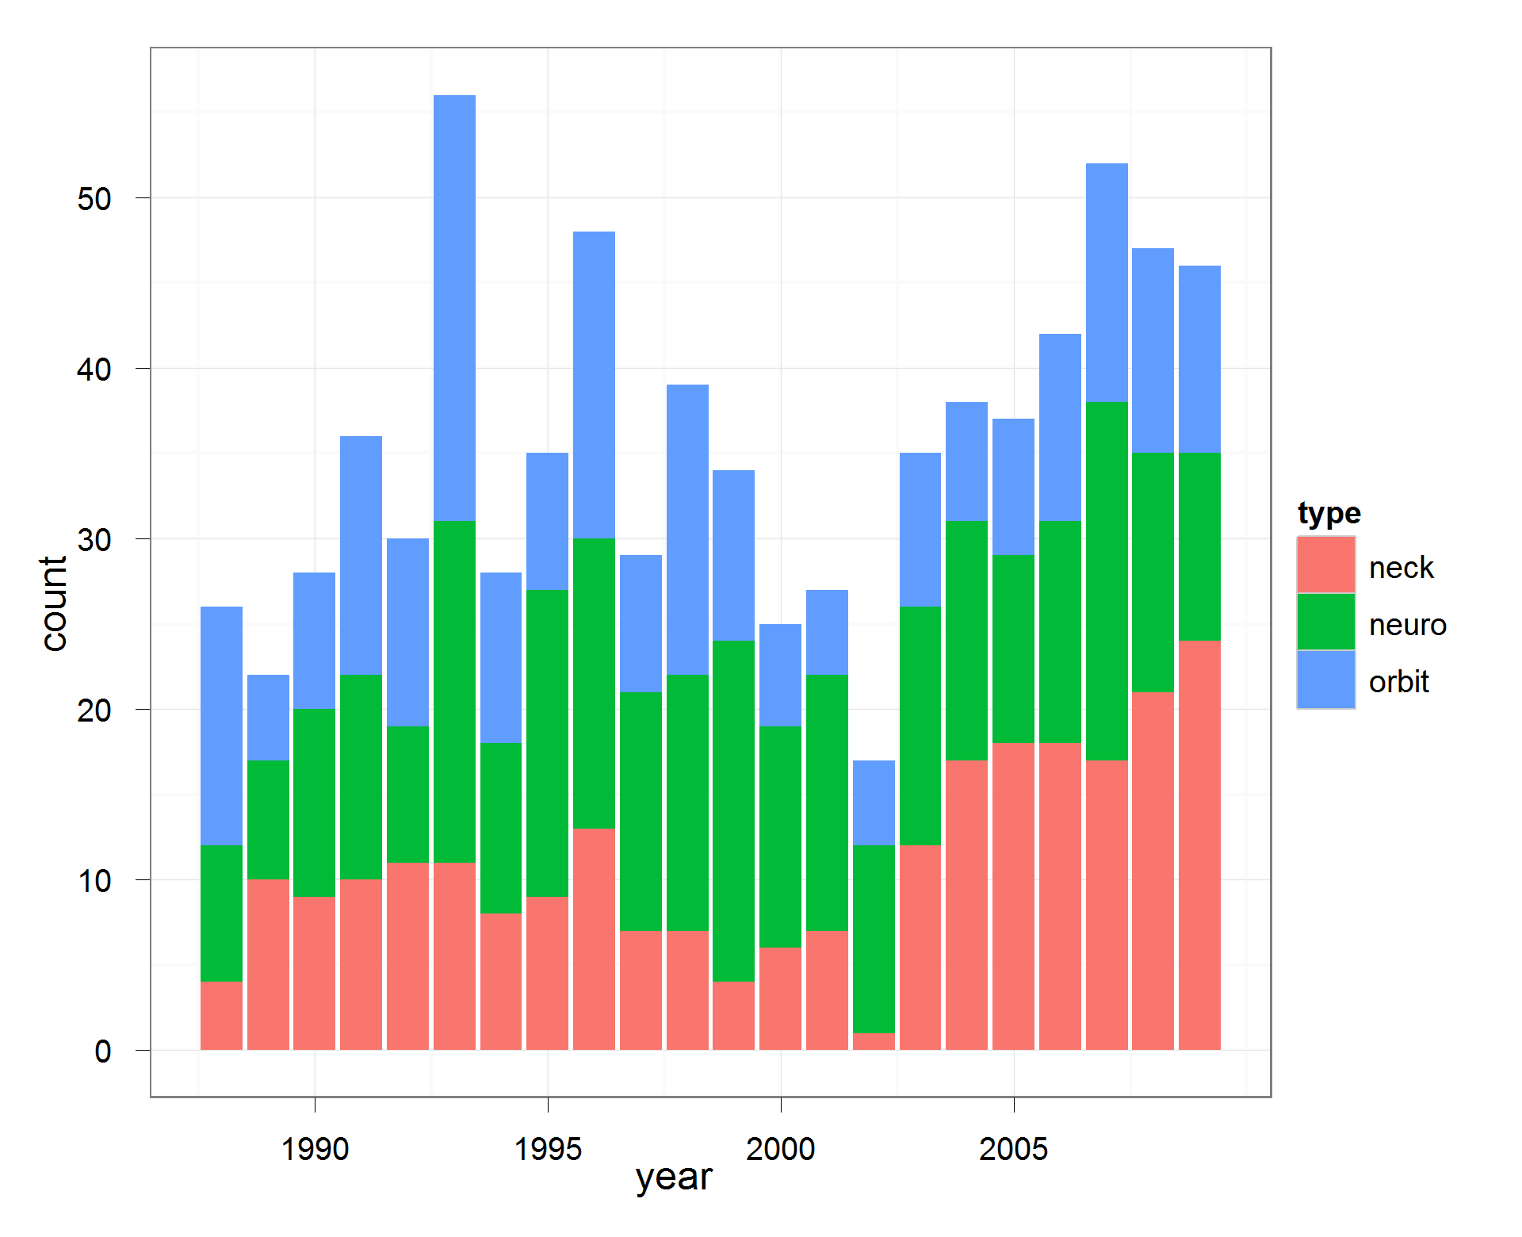

**Figure 2: Rate of High-Risk Surgeries over Time (by Year)**

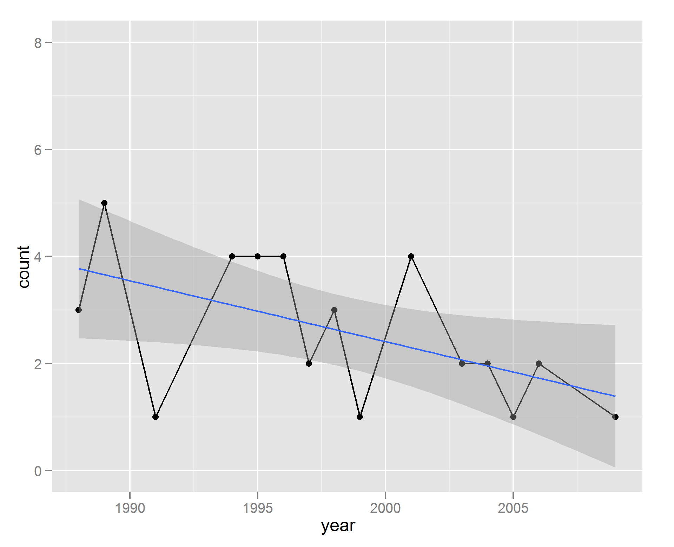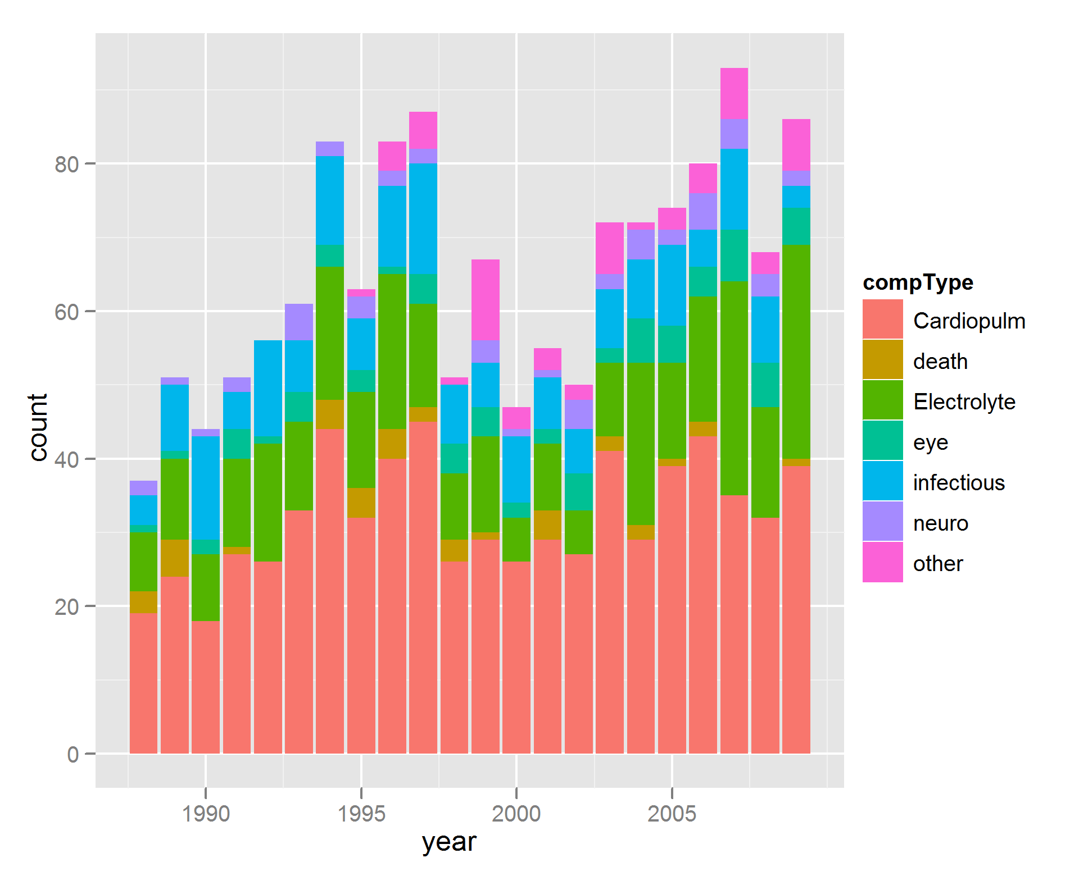

**Figure 3: Rate of Surgery-Related Morbidity and Mortality over Time (by Year)**

**Discussion**

Sinonasal cancers are a highly heterogeneous collection of morbid neoplasms often initially treated with surgery and adjuvant radiotherapy. Initially, these cancers can be clinically silent or mimic benign disease such as sinusitis or upper respiratory infections, as evidenced by a relatively high proportion of locally advanced extent at presentation. Demographic analysis reveals our findings are consistent with population based data from SEER, showing a male predominant patient population mostly between 50 – 70 years of age that has not significantly changed in incidence over the last twenty years [9]. Our data did not show significant changes over time in patient race or insurance status.

Tumor staging is not possible with the NIS, but paranasal sinus tumors are defined as advanced stage by spread beyond the paranasal sinuses to the cranial vault, orbit, or other local structures, or via lymphatic spread. Thus the prevelance

of advanced disease at initial presentation is demonstrated by the fact that 20.2% of cases in this database and 50% of patients treated at higher volume centered underwentsurgery with neck dissection, had orbital or maxillary sinus involvement, or had skull base involvement. The data reveals an increase in the number of complex cases has only increased over time, with an especially marked increase in the number of cases with neck dissection (Supplemental Figure E). Causes for this are not immediately clear and could be due to better detection of advanced disease, improved recognition of disease pathology, or more aggressive management philosophies. Previous case series have also shown between 39%-95% of cases present initially with advanced disease (Stage III or IV)[1,8]. There does not appear to be a trend over time for lower stage at initial presentation, as evidenced by even recent case series having high proportion of advanced disease (74% between 1995 – 2004 in Denmark[4]).

Advances in surgical management of sinonasal cancer could explain the higher rates of referral over time to high-volume, experienced centers. Previous studies have shown decreased morbidity, decreased mortality, and deceased length of stays at high-volume centers for the surgical management of a variety of head and neck cancers [10, 11, 12]. High volume surgeons, more commonly found at high volume centers, have also been found to have decreased perioperative complications, improved long term survival in cancer, and reduced hospital costs [13 – 16]. These effects were especially seen in complicated cases [16]. The increased referral over time to high-volume, experienced centers could be explained by the increased incidence of complex sinonasal cases over time. Particularly in cases with skull base involvement, it could be advantageous to have surgery at a high-volume center with an integrated approach with neurosurgical support. Alternatively, since this study lacks tumor staging data, it is possible that equivalently staged tumors are treated with less aggressive surgeries at low volume centers.

Although there has been an increase in the number of complex cases performed, there has been a decrease in perioperative mortality for sinonasal cancer surgeries. Prior studies of skull base surgery have demonstrated an improved mortality over the past 40 years primarily due to decreased infectious rates and better reconstructive techniques. This has allowed more aggressive, larger surgeries without an increase in mortality. Concurrently, this would also explain theobserved increase in overall morbidity over time. The incidence of infectious complications has gone down over time, while there in has been an increase in the number of electrolyte abnormalities and ardiopulmonary complications. Further, surgeons are operating on older patients.

Even though high-volume institutions provide care for more high-risk cases, but there was no difference in the mortality rate between high- and low-volume centers. There was no difference in the incidence infectious complications or surgical complications (neuropathies, visual disturbances, or hemorrhage). High-volume institutions had a higher rate of cardiopulmonary complications and electrolyte complications, suggesting that perhaps larger surgeries were attempted which required more aggressive volume resuscitation. Increases in incidence of these two categories of complications also leads to an increased overall complication rate at high volume hospitals.

One limitation of this study is that the National Inpatient Sample does not keep track of long-term outcomes from these hospitalizations. While we were able to show there is little perioperative mortality (0.8%), we were unable to examine long-term survival or complications. Further investigation would be necessary to compare the efficacy of various treatment options.

Citations

[1] MDACC <http://www.ncbi.nlm.nih.gov/pubmed?term=18164845> n = 62

[2] Barnes L, Tse LLY, Hunt JL, et al. Tumours of the nasal cavity and paranasal sinuses: Introduction. In: Pathology and Genetics of Head and Neck Tumours, Barnes L, Eveson JW, Reichart P, Sidransky D. (Eds), IARC, Lyon 2005. p.9.

[3] FLORIDA <http://www.ncbi.nlm.nih.gov/pubmed/3335447/> n = 48

[4] DENMARK <http://www.ncbi.nlm.nih.gov/pubmed?term=20001493> n = 242

[5] UCLA <http://www.ncbi.nlm.nih.gov/pubmed/11753979>

[6] WASHU <http://www.ncbi.nlm.nih.gov/pubmed/2846481> n = 62

[7] Earlier Denmark <http://www.ncbi.nlm.nih.gov/pubmed/11321654> n = 315

[8] West Africa <http://www.ncbi.nlm.nih.gov/pmc/articles/PMC2575924/> n = 82

[9] <http://onlinelibrary.wiley.com/doi/10.1002/hed.21830/full>

[10] Oropharyngeal <https://vpn.ucsf.edu/pubmed/,DanaInfo=www.ncbi.nlm.nih.gov+22241647>

[11] Laryngeal https://vpn.ucsf.edu/pubmed/,DanaInfo=www.ncbi.nlm.nih.gov+22052419

[12] Oropharyngeal https://vpn.ucsf.edu/pubmed/,DanaInfo=www.ncbi.nlm.nih.gov+21433017

[13] <https://vpn.ucsf.edu/pubmed/,DanaInfo=www.ncbi.nlm.nih.gov+14645640>

[14] <https://vpn.ucsf.edu/pubmed/,DanaInfo=www.ncbi.nlm.nih.gov+17457171>

[15] <https://vpn.ucsf.edu/pubmed/,DanaInfo=www.ncbi.nlm.nih.gov+12860752>

[16] https://vpn.ucsf.edu/pubmed/,DanaInfo=www.ncbi.nlm.nih.gov+18600379

[17] http://www.ncbi.nlm.nih.gov/pubmed/17309980

[18] <http://archotol.jamanetwork.com/article.aspx?articleid=484651>

[19] <http://www.cancerstaging.org/products/pasteditions.html>

[20] http://www.ncbi.nlm.nih.gov/pubmed/11753979

[21] <http://onlinelibrary.wiley.com/doi/10.1002/lary.22447/full>